DOCUMENTATION

MODULE 2

POWER BI ASSIGNMENT 1 – DATA TRANSFORMATION & DATA MODELING

E-Commerce Sales Data Analysis Using Power BI

PART A — IMPORTING THE DATA
Step 1: Import List of Orders.csv
- Open Power BI Desktop.
- Click Home - Get Data - Text/CSV.
- Select List of Orders.csv.
- Click Transform Data instead of Load.
This opens the Power Query Editor.
The List of Orders dataset was imported into Power BI using the Text/CSV data source. Power Query Editor was used to perform data cleaning and transformation before loading the data into the Power BI data model.

Step 2: Import Order Details.csv
Inside Power Query Editor:
- Click Home - New Source - Text/CSV.
- Select Order Details.csv.
- Click OK.

Step 3: Import Sales target.csv
Repeat the same process:
- Click Home -New Source - Text/CSV.
- Select Sales target.csv.
- Click OK.
You should now have three tables:
- List of Orders
- Order Details
- Sales target

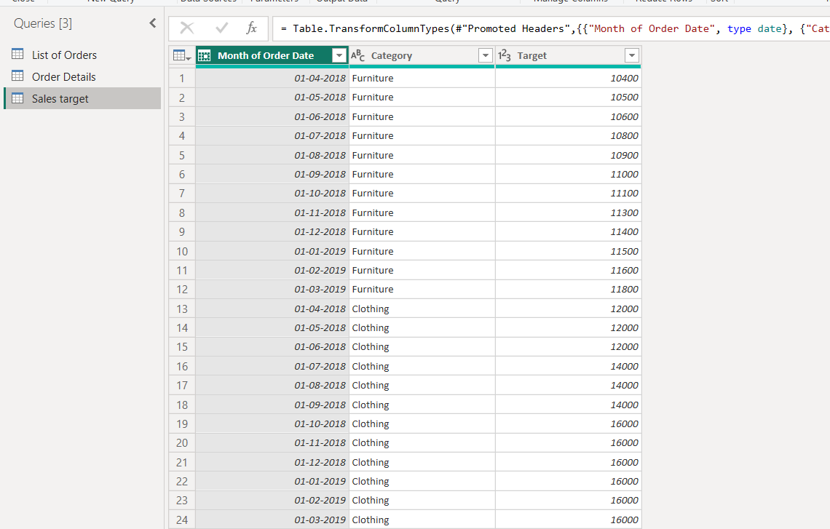

PART B — DATA TRANSFORMATION
Step 4: Keep Only the First 500 Rows
Select the List of Orders table.
Go to:
Home → Keep Rows → Keep Top Rows
Enter:
500
Click OK.
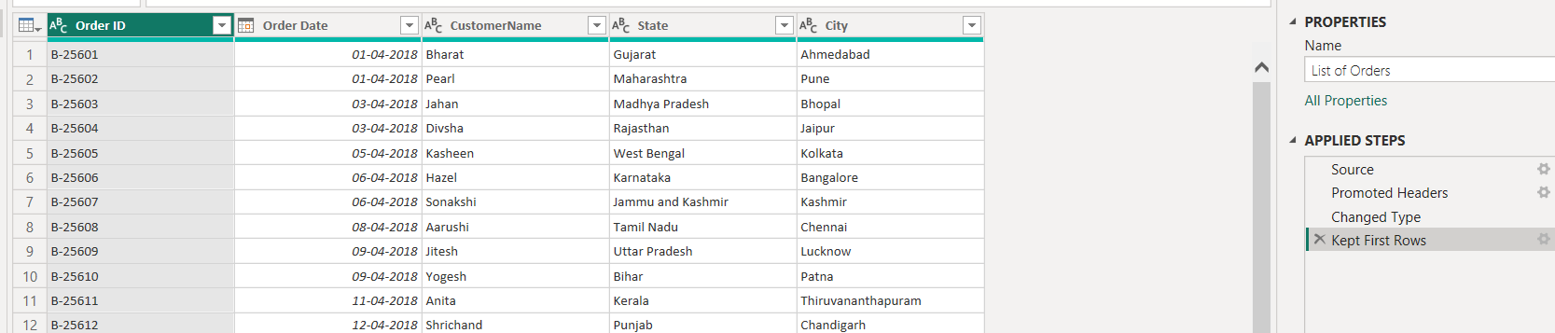

Step 5: Change Order Date to Date Type
Select the Order Date column.
Go to:
Transform → Data Type → Date
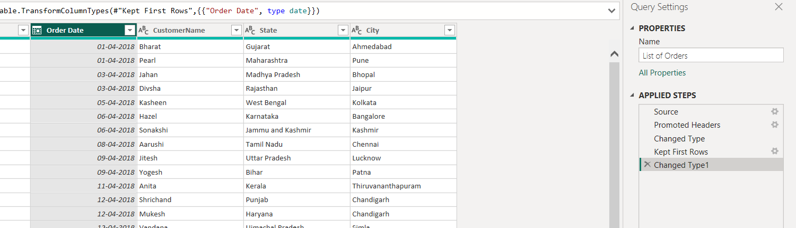
Step 6: Change Amount to Fixed Decimal Number
Open the Order Details table.
Select the Amount column.
Go to:
Transform → Data Type → Fixed Decimal Number
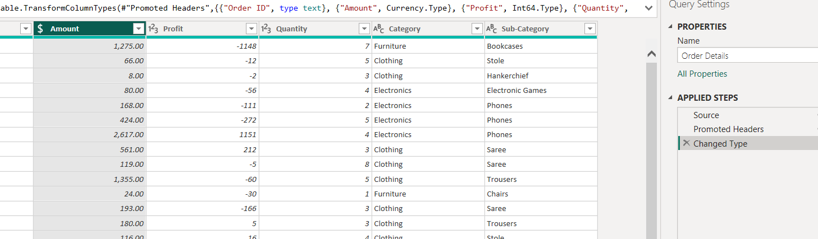
Step 7: Change Target to Fixed Decimal Number
Open the Sales target table.
Select the Target column.
Go to:
Transform → Data Type → Fixed Decimal Number
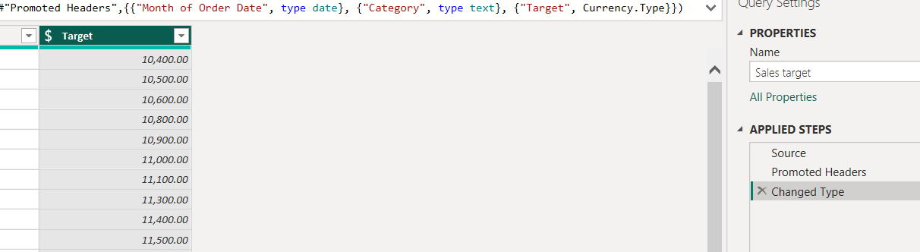

Step 8: Convert CustomerName to Proper Case
Go to the List of Orders table.
Select the CustomerName column.
Choose:
Transform → Format → Capitalize Each Word
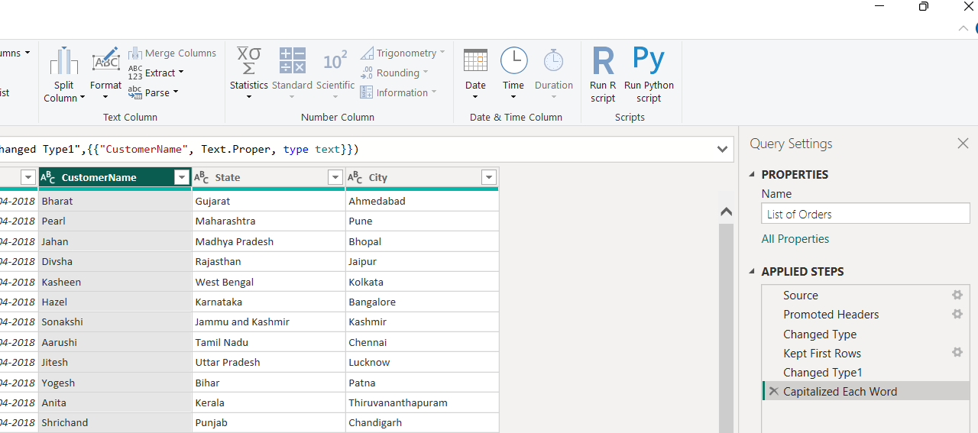
Step 9: Create a Location Column
The requirement is to combine:
City + State
in the format:
City, State
Merge Columns
- Select the City column.
- Hold Ctrl and select the State column.
- Go to:
Transform → Merge Columns
- Choose separator:
Comma
- Rename the new column:
Location
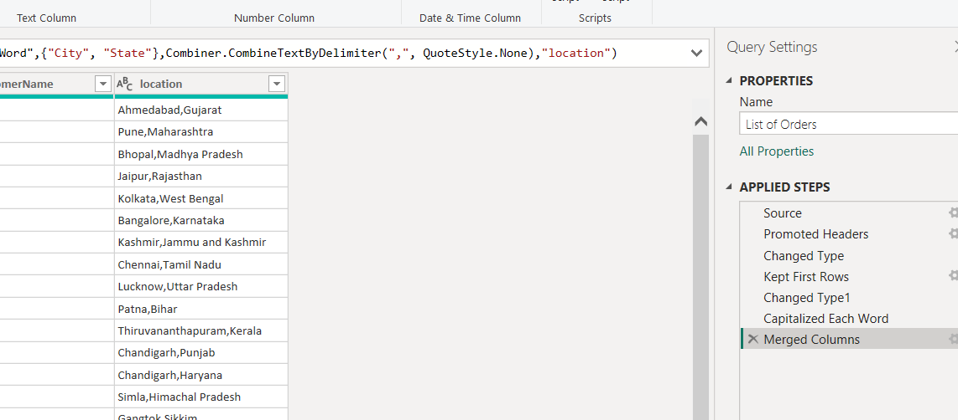
Step 10: Create the Profit Margin Column
Go to the Order Details table.
Click:
Add Column → Custom Column
Column name:
Profit Margin
Formula:
if [Amount] = 0 then null else [Profit] / [Amount]
Click OK.
Then change the column data type to:
Percentage
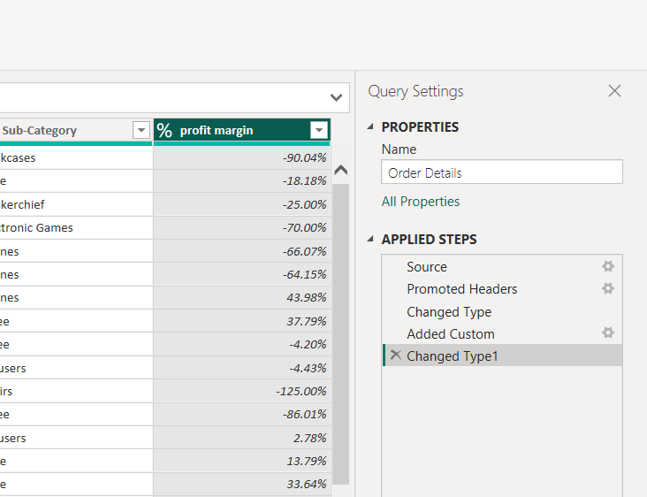

Step 11: Create the Profit Status Column
Go to:
Add Column → Conditional Column
Create the following conditions:
Condition | Output
Profit is less than 0 | Loss
Profit equals 0 | Break-Even
Profit is greater than 0 | Profit
The logic can also be created using a custom column:
if [Profit] < 0 then "Loss"
else if [Profit] = 0 then "Break-Even"
else "Profit"
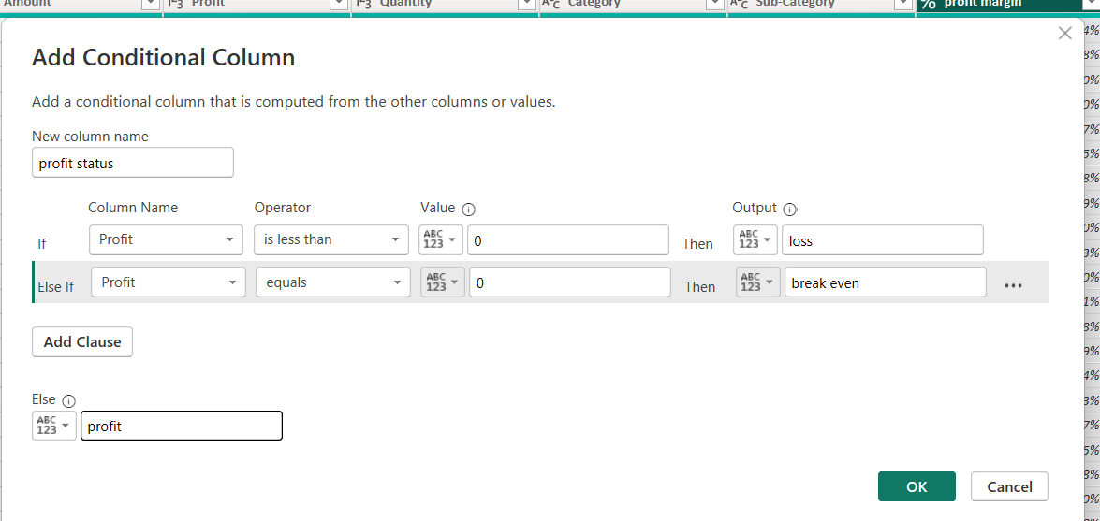
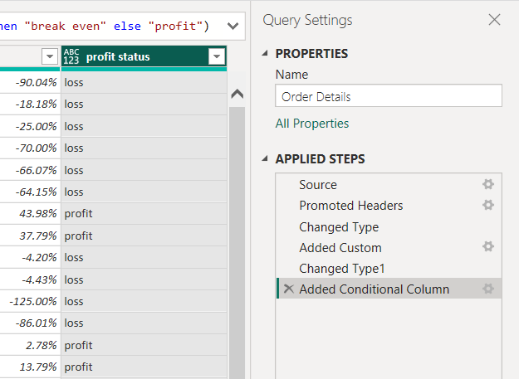
PART C — MERGING DATA
Step 12: Merge List of Orders and Order Details
The two tables should be merged using:
Order ID
Steps
- Select the List of Orders table.
- Go to:
Home → Merge Queries → Merge Queries as New
- Select:
- First table: List of Orders
- Second table: Order Details
- Select Order ID in both tables.
- Join type:
Left Outer Join
This keeps all records from List of Orders and matching records from Order Details.
- Click OK.
- Rename the new table:
Orders Data
- Click the expand icon in the merged column.
- Select the required columns from Order Details, such as:
- Amount
- Profit
- Quantity
- Category
- Sub-Category
- Profit Margin
- Profit Status

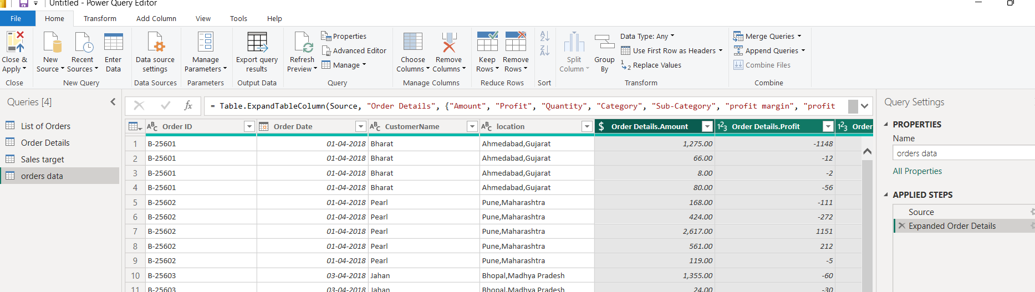

PART D — HANDLING MISSING VALUES
Step 13: Identify Missing Values
In Power Query, check each column for:
- Null values
- Blank values
- Errors
You can use the filter dropdown of each column.
Possible Strategies
Data Type | Suggested Strategy
Customer Name | Replace missing values with "Unknown"
Category | Replace with "Unknown" if appropriate
Amount | Investigate; replace only if justified
Profit | Investigate missing records
State/City | Replace with "Unknown"
Order ID | Remove rows if essential ID is missing
Example
Select a column and choose:
Transform → Replace Values
Replace:
null → Unknown
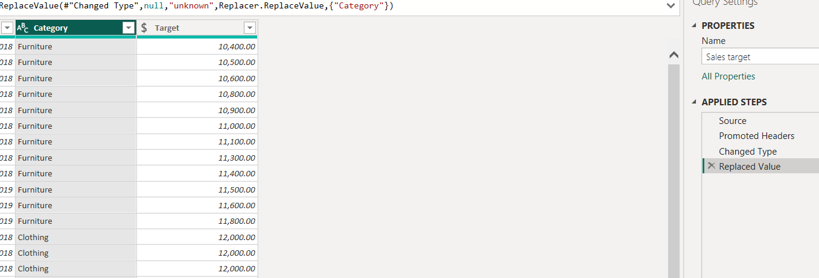

PART E — HANDLING DUPLICATE DATA
Step 14: Check for Duplicate Rows
To check duplicates
- Select the relevant columns.
- Go to:
Home → Remove Rows → Remove Duplicates
For a complete duplicate check, select all columns before removing duplicates.
Recommended Strategy
Do not remove rows simply because the Order ID appears more than once.
An order may contain multiple products, so repeated Order IDs can be valid.
Only remove records that are exact duplicate transactions.
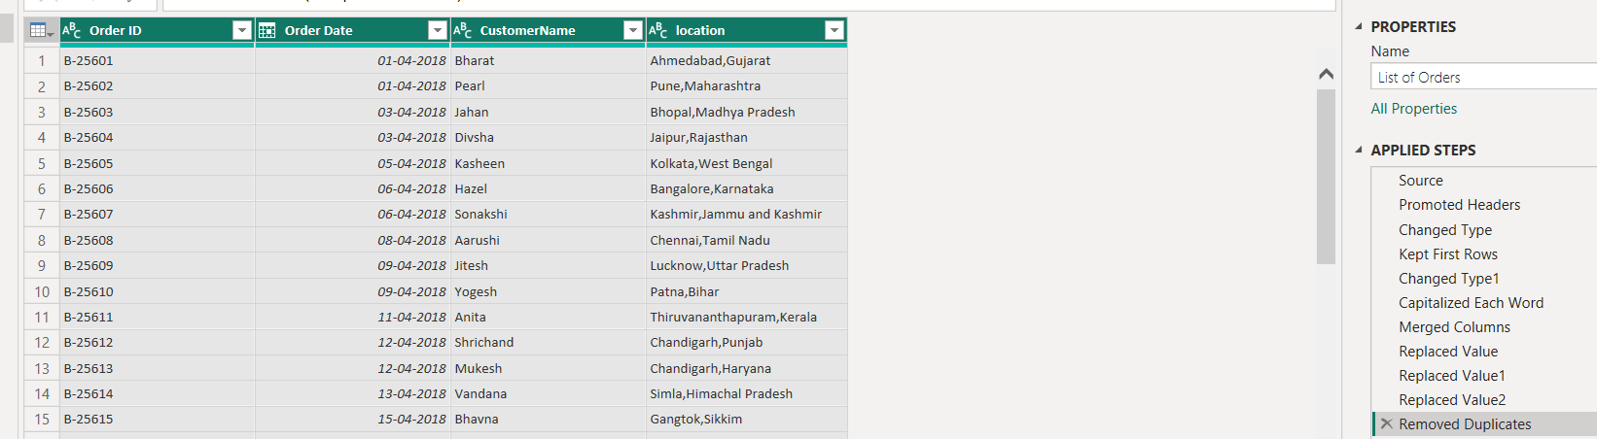
PART F — SORTING AND FILTERING
Step 15: Sort Orders by Order Date
After loading the data:
- Go to Data View or Report View.
- Select Orders Data.
- Sort Order Date in:
Descending Order
This displays the most recent orders first.
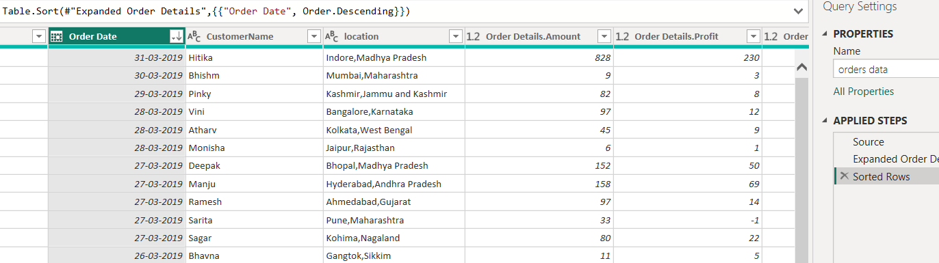
Step 16: Filter Tamil Nadu Orders
You can use:
Option 1: Filter Pane
- Drag State into Filters.
- Select:
Tamil Nadu
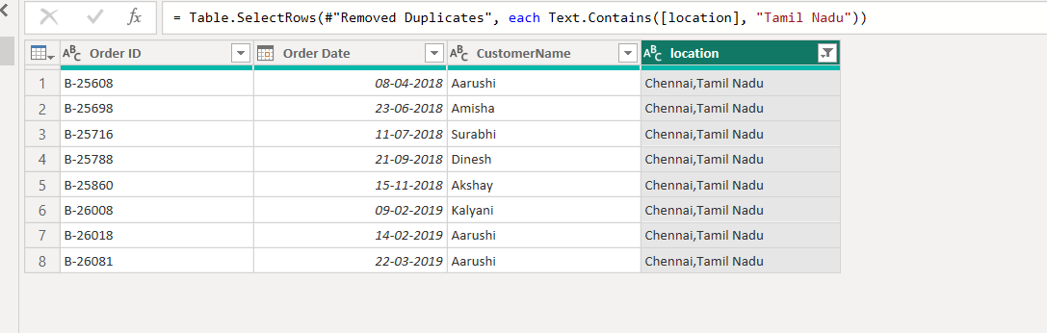.
PART G — GROUPING AND AGGREGATING DATA
Step 17: Duplicate Order Details Table
Right-click Order Details.
Select:
Duplicate
Rename it according to the analysis.
A. Count of Each Order ID
Select:
Order ID
Then:
Transform → Group By
Settings:
- Group by: Order ID
- New column name: Order Count
- Operation: Count Rows

B. Average Profit by Category
Duplicate Order Details again if required.
Go to:
Transform → Group By
Settings:
- Group by: Category
- New column: Average Profit
- Operation: Average
- Column: Profit
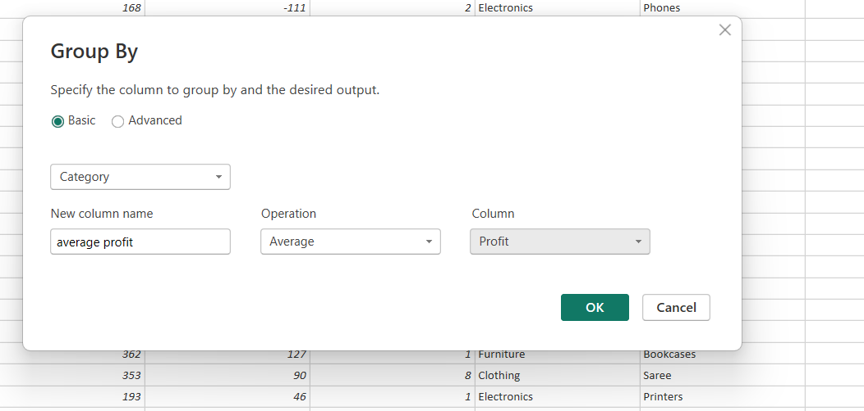
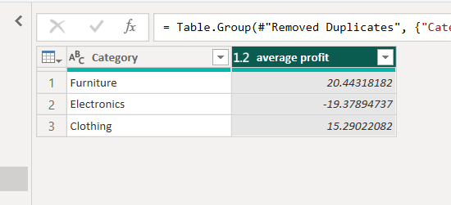

C. Total Amount by Sub-Category
Again use:
Transform → Group By
Settings:
- Group by: Sub-Category
- New column: Total Amount
- Operation: Sum
- Column: Amount
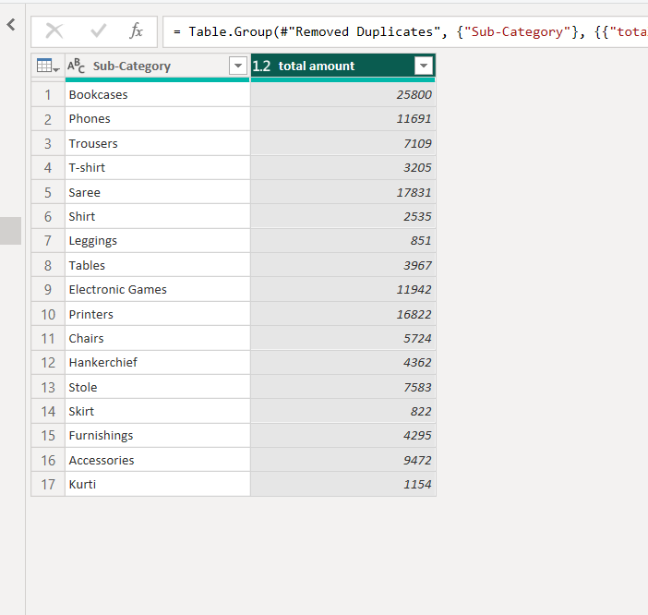

PART H — SALES TARGET AGGREGATION
Step 18: Duplicate Sales Target Table
Right-click:
Sales target → Duplicate
Rename it:
Sales Target Summary

Aggregate Total Target
Use:
Transform → Group By
Group according to the available month/date field.
For example:
- Group by: Month of Order Date
- New column: Total Target
- Operation: Sum
- Column: Target
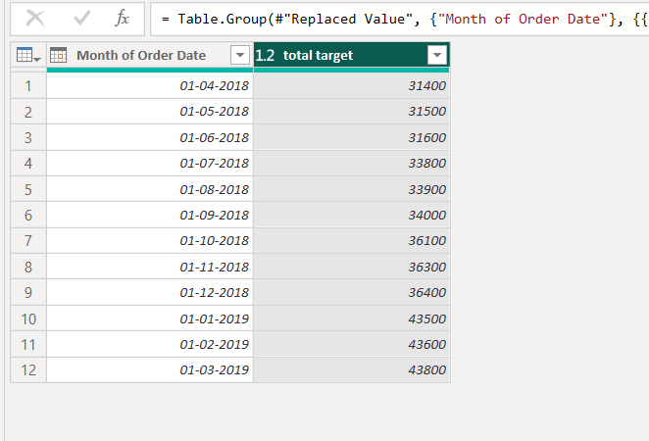

PART I — DATA MODELING
After completing the transformations:
Click:
Home → Close & Apply
Then go to:
Model View.

Step 19: Relationship Between List of Orders and Order Details
Create a relationship using:
Order ID
Recommended relationship:
List of Orders[Order ID]
↓
Order Details[Order ID]
Depending on the uniqueness of the Order ID column, the relationship will usually be:
One-to-Many
List of Orders (1) ─────────── (*) Order Details
Steps
- Go to Model View.
- Drag Order ID from List of Orders to Order ID in Order Details.
OR:
Home/Modeling → Manage Relationships → New
Configure:
Setting | Value
Table | List of Orders
Column | Order ID
Related Table | Order Details
Related Column | Order ID
Cardinality | One-to-Many
Cross-filter direction | Single
Active | Yes

Step 20: Relationship Between Order Details and Sales Target
The assignment requires a relationship using:
Category
Go to:
Modeling → Manage Relationships → New
Configure:
Setting | Value
Table | Order Details
Column | Category
Related Table | Sales target
Related Column | Category
Active | Yes
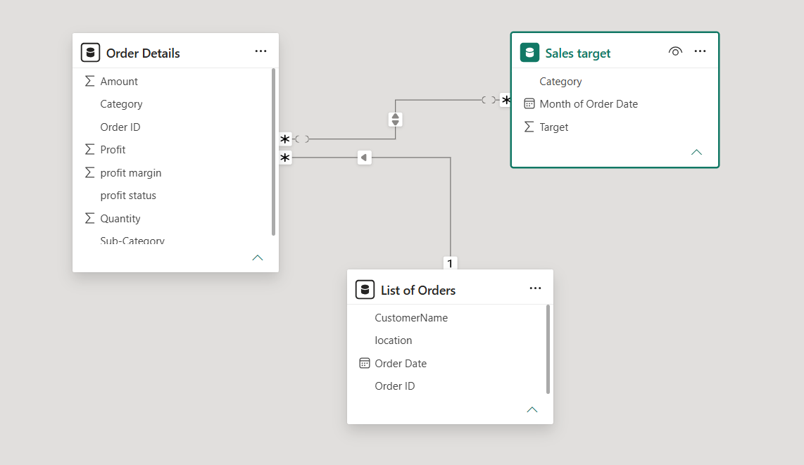

PART J — SUGGESTED POWER BI REPORT VISUALS
After completing the transformation and modeling, you can create the following dashboard.
Page 1: Sales Overview
KPI Cards
Create cards for:
- Total Sales
- Total Profit
- Total Quantity
- Average Profit Margin
Suggested DAX measures:
Total Sales = SUM('Orders Data'[Amount])
Total Profit = SUM('Orders Data'[Profit])
Total Quantity = SUM('Orders Data'[Quantity])
Average Profit Margin = AVERAGE('Orders Data'[Profit Margin])

Page 2: Category Analysis
Clustered Column Chart
- Axis: Category
- Values: Total Sales
Bar Chart
- Axis: Sub-Category
- Values: Total Profit
This helps identify high-performing and low-performing product groups.
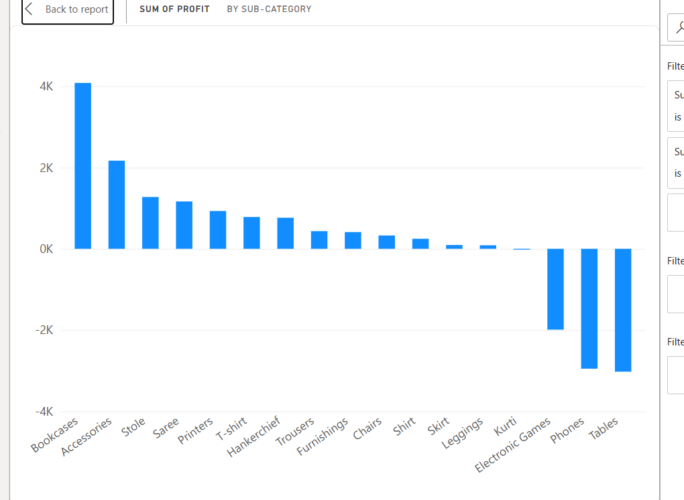
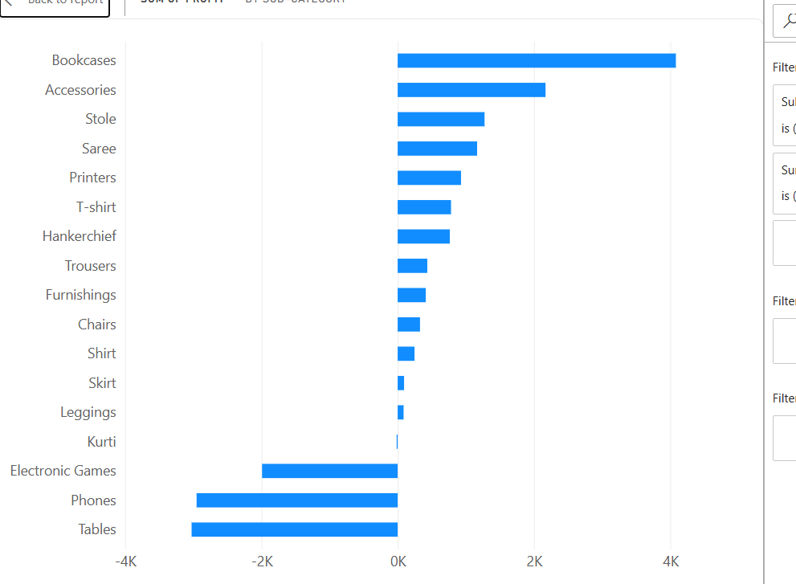
Page 3: Regional Analysis
Map or Bar Chart
- Location: Location
- Values: Total Sales
State Slicer
Use:
State
Select Tamil Nadu to perform regional analysis.
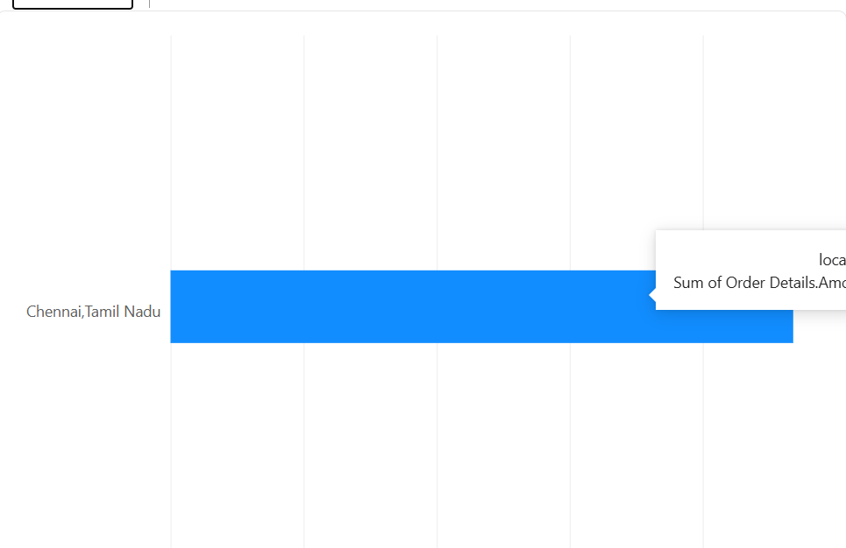
Page 4: Time Trend Analysis
Line Chart
- X-axis: Order Date
- Y-axis: Total Sales
Sort the dates to observe sales trends over time.
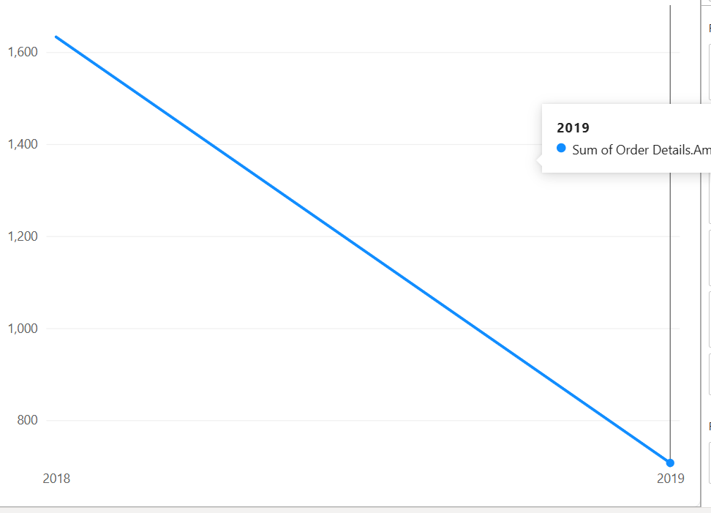
Page 5: Profit Analysis
Donut or Pie Chart
- Legend: Profit Status
- Values: Count of Orders
This shows the proportion of:
- Profit
- Loss
- Break-Even

